Introduction To Statistics For Data Science

Durham University

Workshop 4 Team Questions
Discuss each of these three questions in your team. At various points, I will ask each team to hold up a card marked A, B, or C, to show which answer you have selected for each question. I’ll then ask for volunteers to explain why the team selected their answer.

Question 1

A medical statistician performs a statistical test, at the 5% level of significance, to investigate whether a new form of exercise regimen will help asthma patients control their breathing, compared to an older exercise regimen. The null hypothesis is that each regimen is equally effective. The alternative hypothesis is that they are not equally effective.
The p-value for the statistical test is 0.074.
Which one of the following statements is true?
A) The statistician must reject the null hypothesis.
B) The statistician must fail to reject the null hypothesis.
C) The statistician must accept the null hypothesis.

Question 2

Which of the flowcharts below describes the most efficient process by which we can determine which statistical test to use when testing whether the population means for two data samples are different, under the null hypothesis that the population means are equal?

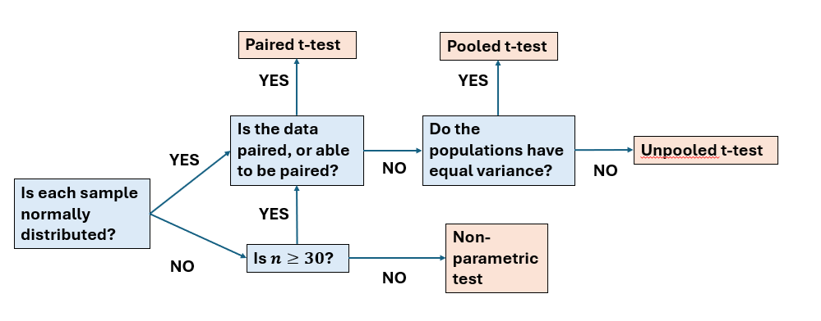

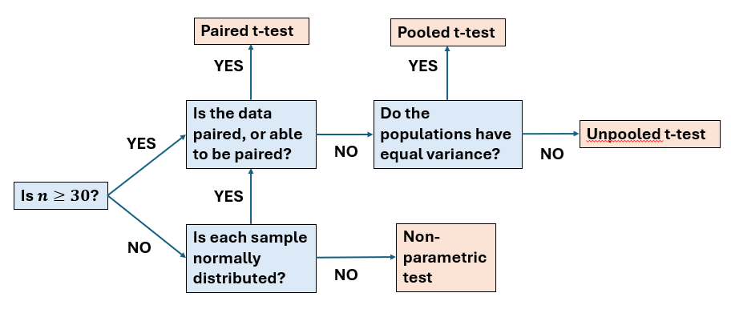

C)

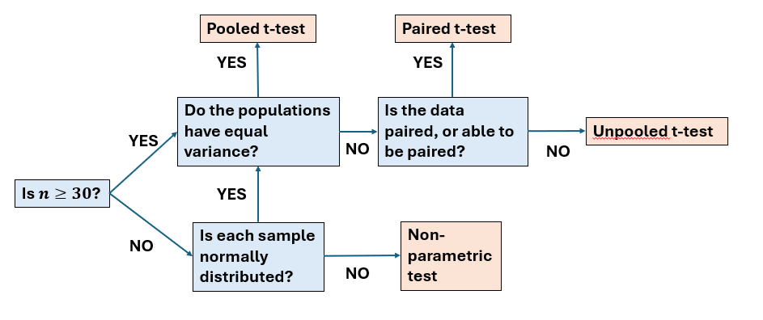

Question 3

In some places, when an election is tied, the winner is determined by a coin toss. A data scientist is tasked with checking whether the coin being used to choose a winner in tied elections is fair. The null hypothesis is that p=0.5, where p is the probability of the coin coming up heads. The alternative hypothesis is that p $≠$ 0.5
The coin is flipped six times, with the results H, H, T, T, T, H.* What is the p-value for the statistical test for this null hypothesis?

0.016

0.5

1
*This is a very small number of tests, which in the real world would probably get the data scientist in trouble for doing so little work!

